# 08. JS Basics

**Name: Ali Sarwar**

1. **Question: Reverse a string without using the built-in reverse() method**.

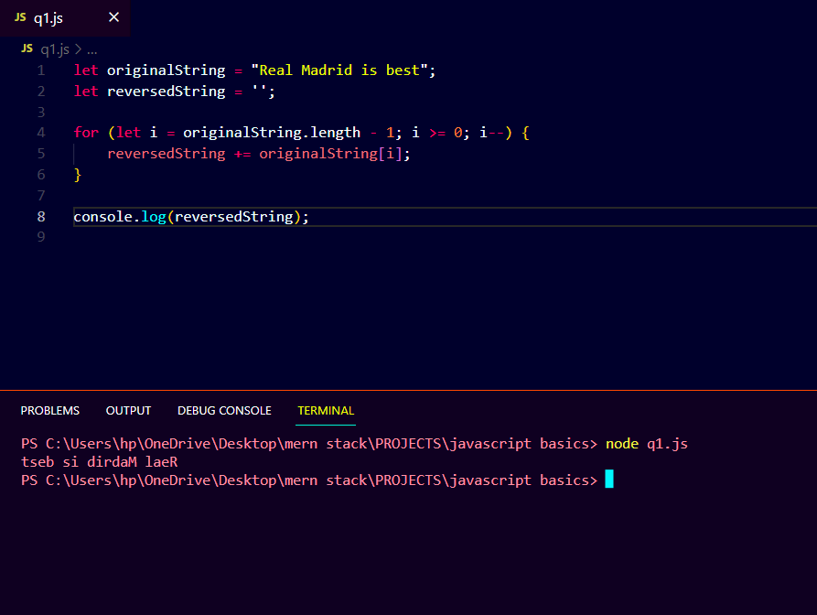

1. **Question: Count the number of vowels in a given string**.

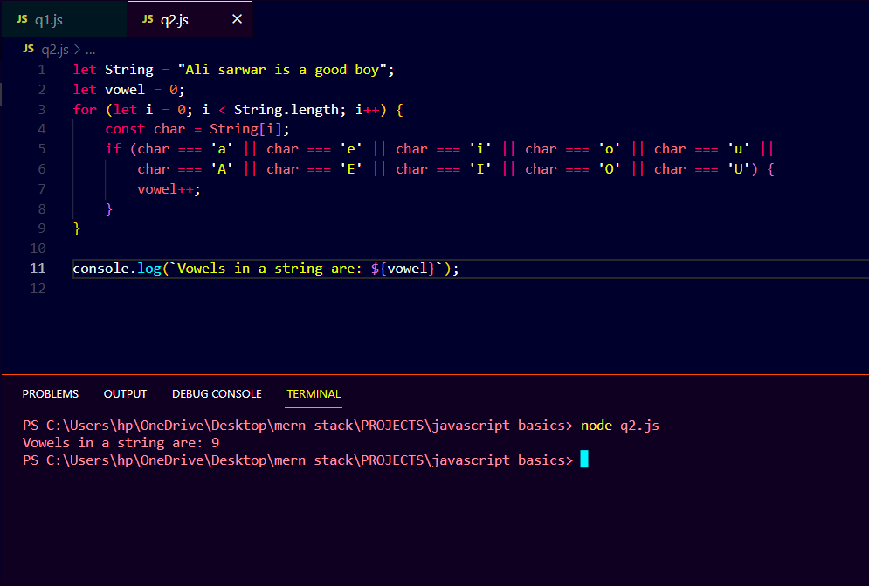

1. **Question: Convert the first letter of each word in a sentence to uppercase.**

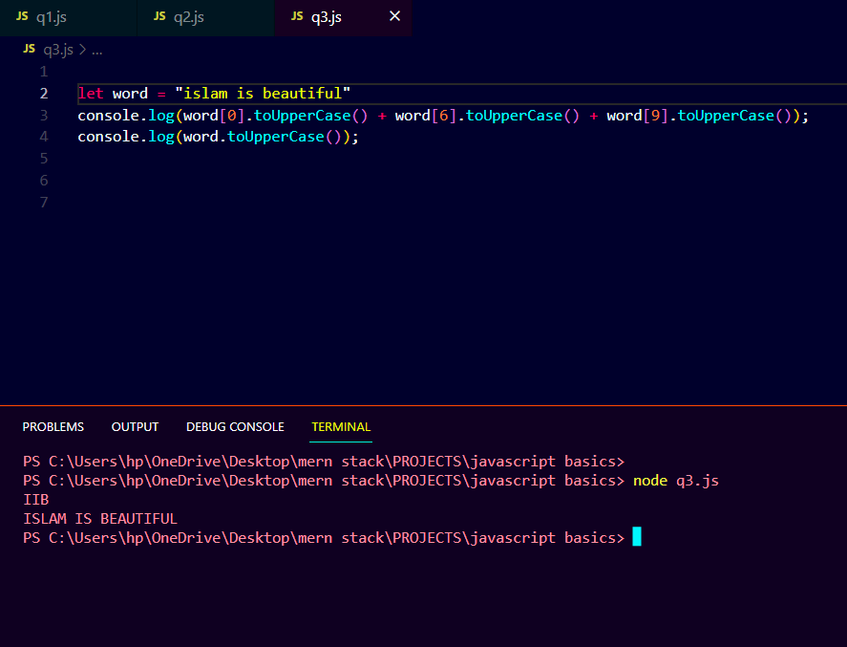

1. **Question: Check if a string is a palindrome.**

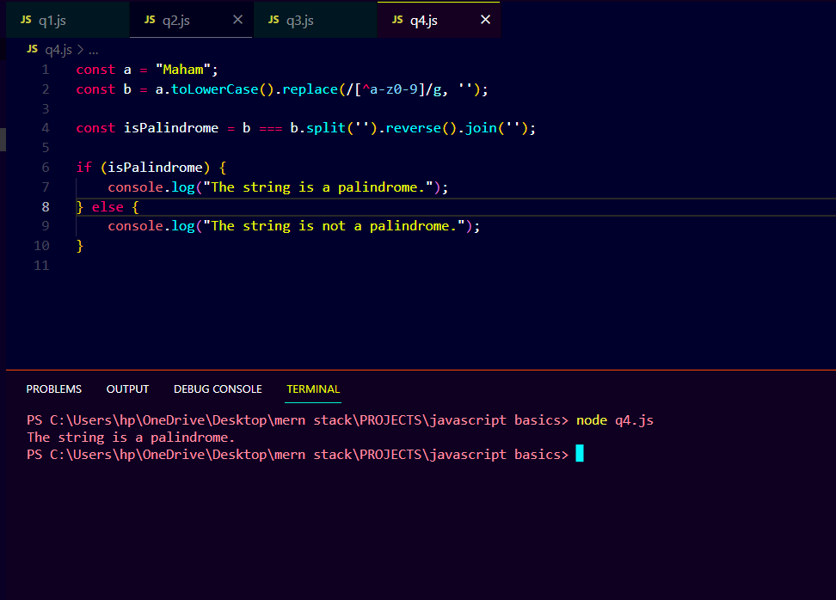

1. **Question: Find the sum of all positive numbers in an array.**

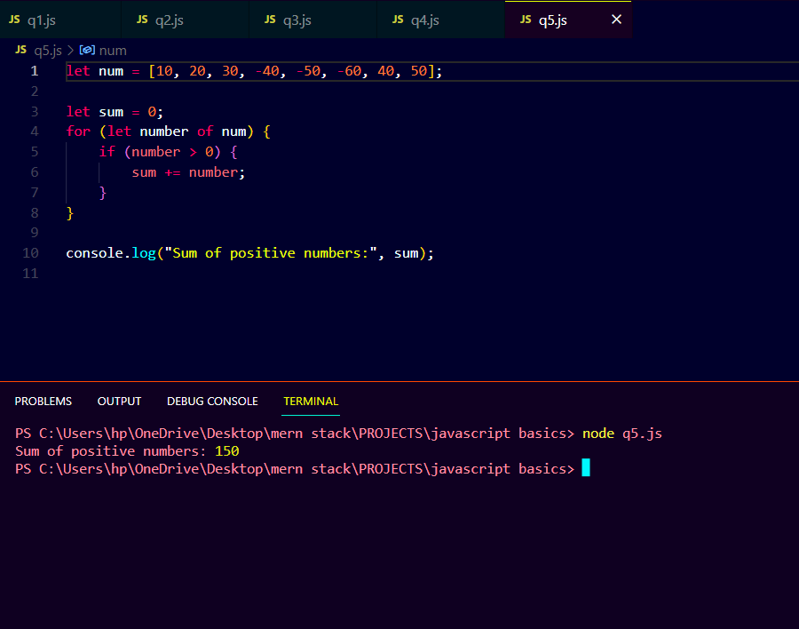

1. **Question: Find the index of the first occurrence of a specific element in an array.**

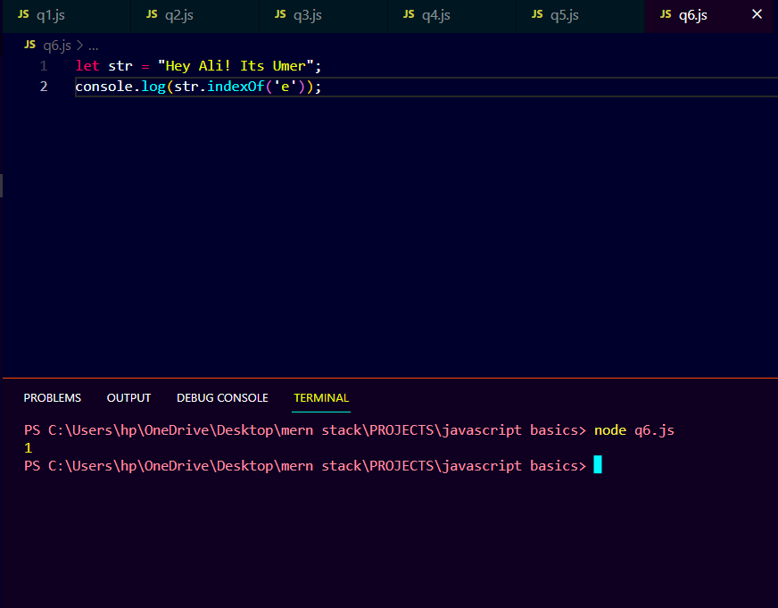

1. **Question: Remove all duplicates from an array without built-in methods.**

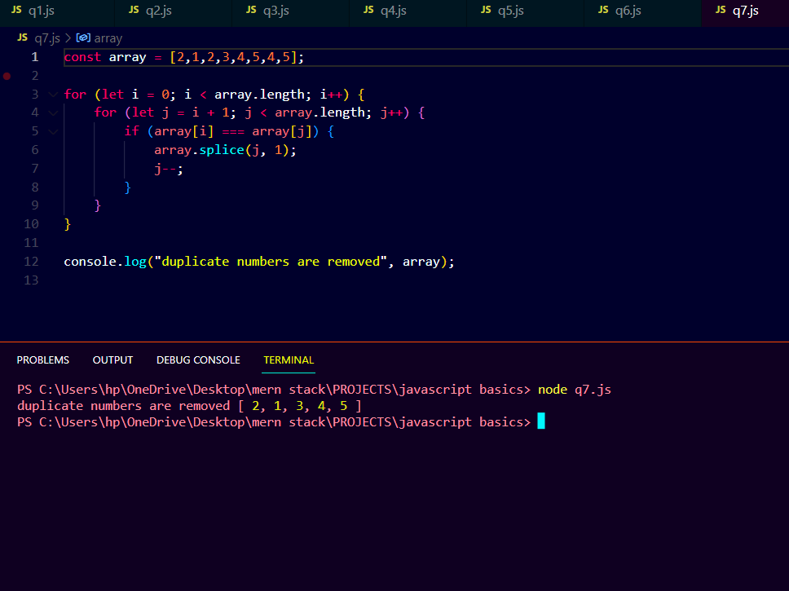

1. **Question: Sort the array in ascending and descending without built-in methods.**

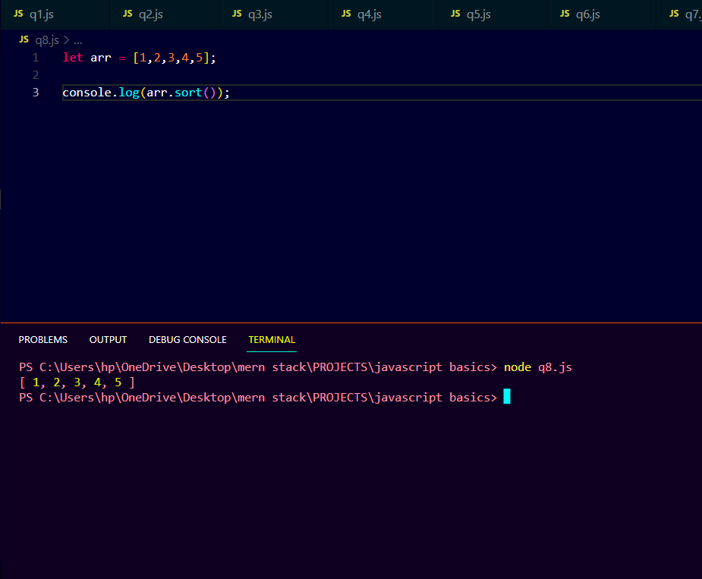

1. **Question: Print all even numbers between 1 and 20 using a while loop.**

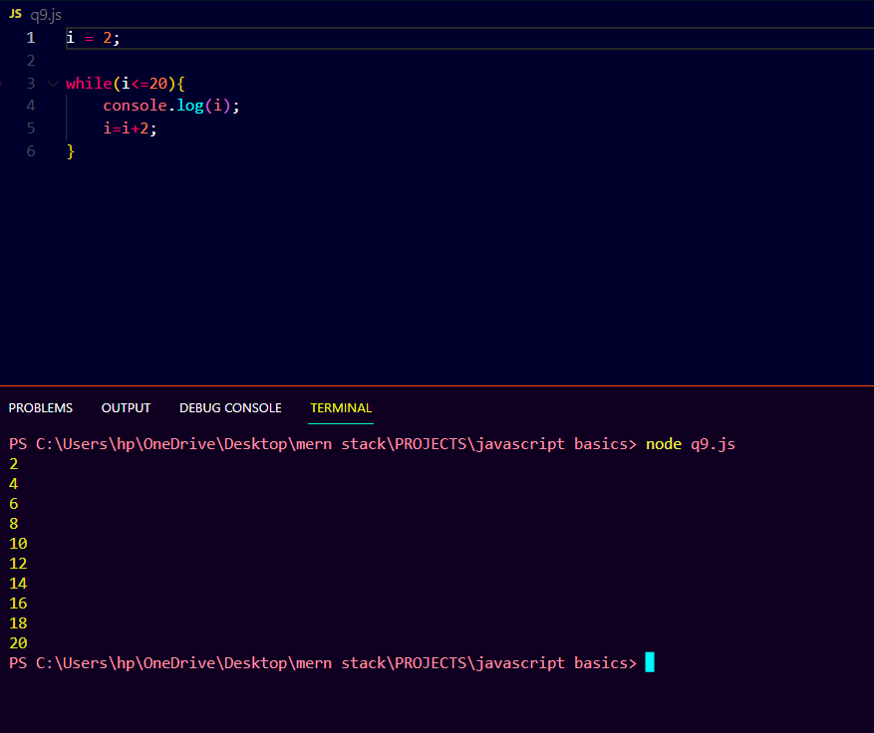

1. **Question: Calculate the factorial of a number using a do-while loop.**

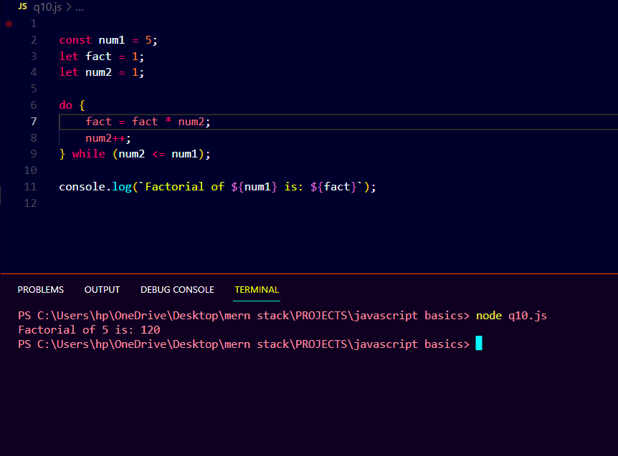

1. **Question: Iterate through the properties of an object using a for-in loop**.

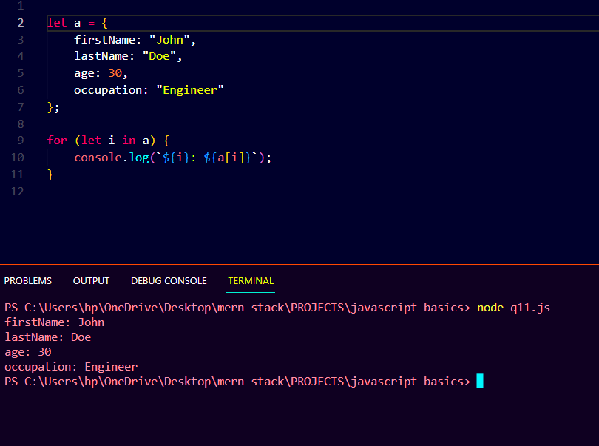

1. Question: Loop through an array using a for-of loop and double each element.

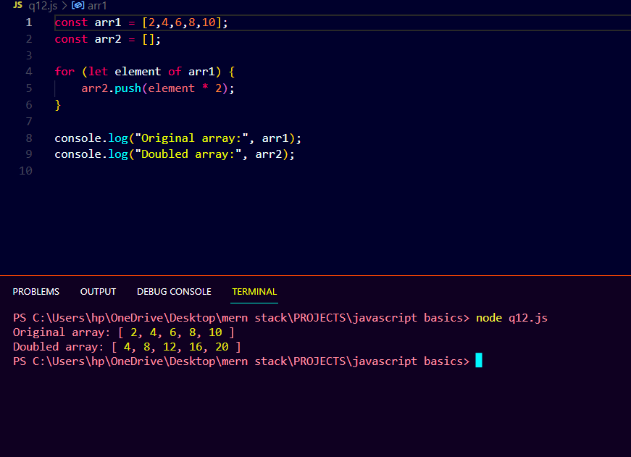

1. **Question: Check if a number is even or odd and return a corresponding message.**

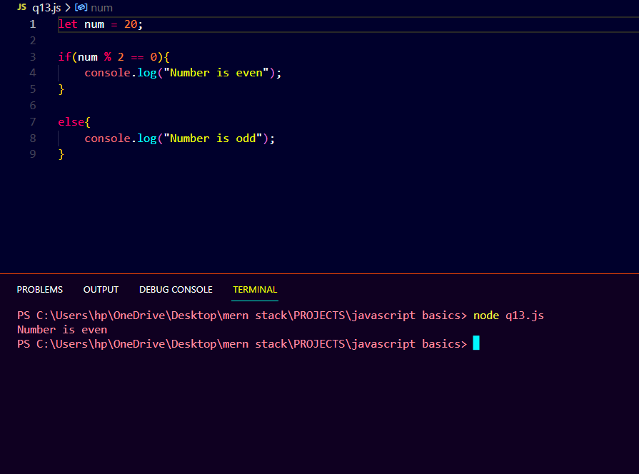

1. **Question: Find the maximum of three numbers using nested ternary operators.**

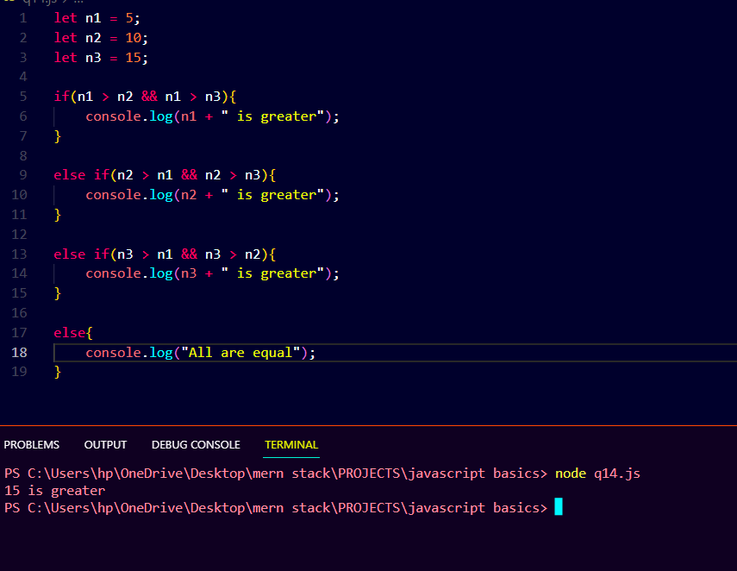

1. **Question: Determine if a year is a leap year or not.**

